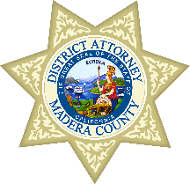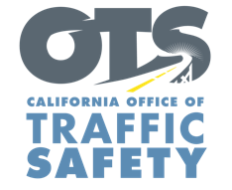

FOR IMMEDIATE RELEASE January 29, 2025

Marta Garcia, 559.395.0600

MaderaDA@maderacounty.com

**Madera County Awarded Grant from the Office of Traffic Safety for Specialized DUI Prosecution Team**

Madera, Calif. –The Madera County District Attorney’s Office will have a specialized prosecution team that handles alcohol and drug-impaired driving cases through a $315,505 grant from the California Office of Traffic Safety (OTS).

“Impaired driving remains a significant danger to other people traveling on roads, particularly with drivers suspected of operating a vehicle under the influence of both alcohol and drugs,” Madera County District Attorney, Sally O. Moreno, said. “This program allows us to focus specifically on holding individuals accountable for impaired driving and make the roads in our community safer for everyone.”

The specialized prosecution team will also partner with the statewide Traffic Safety Resource Prosecutor Training Program (TSRP) to provide training to other prosecutors and investigators, as well as collaborate with law enforcement agencies on best practices for handling and managing driving under the influence (DUI) cases.

This is the third year the Madera County District Attorney’s Office has received funding from the OTS for a specialized (DUI) prosecution program. Last year, the prosecution team filed 53 DUI cases, including 30 DUI drug cases and 10 DUI combined alcohol and drug cases.

The grant program runs through September 2025.

Funding for this program was provided by a grant from the California Office of Traffic Safety, through the National Highway Traffic Safety Administration.



# # #